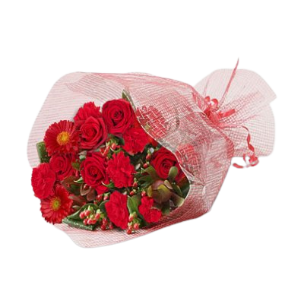

**FLOWER ROSE:**

*7 imported red rose*

*6 imported white spray rose*

*2 gypsum*

*Price: $15.99*